PROJECT ON-

Mobile and computer shopee management SYSTEM

P.D.E.A’S

WAGIRE COLLEGE

SASWAD

DEPARTMENT OF COMPUTER SCIENCE

CERTIFICATE

This is to certify that the project entitled

“ mobile and computer shopee management SYSTEM” has been Satisfactorily and successfully completed by,

* ADLING PANKAJ LAXMAN
* JAGTAP GANESH HANUMANT

For academic year **2015-2016**

As prescribe by Savitribai phule University Of Pune

**Prof. Kakade S.R. Prof. More R.N.**

**(Project Guide) (Head Of Dept)**

**Internal Examiner External Examiner**

**ACKNOWLEDGMENT**

**We would like to express our sincere thanks to all those who were directly or indirectly involved in the making this project entitled “mobile and computer shopee management SYSTEM”.**

**Firstly we are thankful to our project guide PROF. Kakade s.r. the non teaching staff of our college for giving guidance & encouragement to us. We are also thankful**

**To all our friends…………….**

**Last and definitely not the least, we thank our highly esteemed college teachers & our department H.O.D. PROF.MORE.R.N**

**Associated By:-**

1. **Adling Pankaj Laxman**

2. **Jagtap Ganesh Hanumant**

**INDEX**

|  |  |  |
| --- | --- | --- |
| **Sr. No** | **Particulars** | **Page No.** |
| **1.** | **Introduction:**   1. **Introduction of the project** 2. **Need for the project** | **5** |
| **2.** | **Analysis:**   1. **Scope of the system** 2. **Feasibility study** 3. **Fact finding techniques** 4. **Hardware and Software Requirement** | **8** |
| **3.** | **Diagrammatic Representation:**   1. **ER diagram** | **19** |
| **4.** | **Design:**   1. **Data dictionary** 2. **Screen layout:** 3. **Input screen** 4. **Output screen** | **25** |
| **5.** | **Conclusion:** | **59** |
| **6.** | **Bibliography** | **63** |

***INTRODUCTION***

***INTRODUCTION***

**‘Mobile and Computer Records and Billing System’ maintains the records currently on a handwritten-register. Hence information like bill -amount, delivery report is all in a handwritten format.**

**We took it as a challenge to make the same system into a computerized one and to improvise the process. When computerized, the user will have to enter any item, stock just once which will be entered into the database and then fetch according to his need through the drop-down lists or by searching through id.**

**We see forward to provide our users a sigh of relax and to make data-handling easy by the use of our software. We intend to provide User-satisfaction at the utmost.**

NEED FOR THE PROJECT

**The utmost need for the project arose when it was required to make the current system computerize. We went once to find out the current processes and found out the problems under execution of current process.**

**We took it as a challenge to develop a user-friendly system to make it helpful for the Shopee staff to minimize their wastage of time just by improvising the system to a computerized one at a distance of just a few clicks and a few key-presses.**

**ANALYSIS**

**SCOPE OF THE SYSTEM**

* **The Mobile and Computer Shopee Management System is managed using a user-friendly database.**
* **The details of dealer, employee, customer, bill and products at just a few clicks and button presses.**
* **The hand-written system of Mobile and Computer Shopee Management System would become a history.**

* **Utmost security-based system which can prevent the data from getting misused.**

PROPOSED SYSTEM

The existing hand-written system has many drawbacks which lead to the development of a new system which will be a computerized system based on advanced technologies & services, which will overcome most of the drawbacks of the existing system. Computerized system processes quickly than the manual system .The computerized system provides all the required information requested by the user at any time. Manual system generates redundant data which leads to many errors and problem of updating arises. The need for the proposed system is:-

SECURITY:-

This system will provide higher security to the database for the

Convenience of the system developers & users. Data will be secured

from any malpractices or cheat.

USER FRIENDLY:-

The system will be user friendly. The system has a user friendly screen with well arranged menu option for the easy conveniences of the

users.

RELIaBLE:-

The **Mobile and Computer Shopee Management System** will be highly reliable ,as it provides insertion, updatation, deletion, view and search at any time according to the user requirement.

MANAGEMENT OF DETAILED INFORMATION:-

This module will enable the system for keeping the detailed information about all the functions performed by the system. Records are maintained for the entire task performed by the system & also the databases updating is possible.

The system will provide easy user interface to the users for satisfying their requirements by performing different operations.

FEASIBILITY STUDY

While designing any system, the first step is --> the designing of the

requirement analysis. Study of requirement analysis is done through

different feasibility studies:

* Technical Feasibility
* Economical Feasibility
* Operational Feasibility

FEASIBILITY STUDY HELPS:

* To identify the scope of the system to be studied.
* To identify the problems and understand the

opportunities in the current system which may be

manual or auto matched.

* To identify the major objectives of the system.
* To estimate roughly the cost of each possible solution to the user problem and identify those solutions that might satisfy the user’s needs within the budget and schedule.
* To develop the rough estimate of the benefits and drawbacks of each solution.
* To develop the outline of carrying out of the project with an idea of resources required.
* To obtain user and management views on all above procedures.
* To obtain the decision from the user and management on whether to commit atleast analysis part of the project.

1. TECHNICAL FEASIBILITY:-

The technical aspect of feasibility is largely concerned with answering

the questions who, why, where, when, what and how much in the contact of the existing system and the proposed system. An investigation of present procedure is needed in order to identify the volumes, trends and

frequencies that will specify affect the design of any computer based

system. In our projects all these points are handled. Based on this, we have designed the input screens, tables showing list of input fields with different possibilities of validation and their acceptability to the user gauged and correction is done, whenever necessary.

1. ECONOMICAL FEASIBILITY:-

In the economic evaluation, we were concerned with the cost of doing

things in a particular way in order to benefit the department.

The Shopee already had most of the things needed (computer

hardware, computer literate staff). So minimum investment was required.

This system has very less investment and gives plenty of useful

output. This is an economical system, it requires lesser manpower and a

computer with internet connection.

1. OPERATIONAL FEASIBILITY STUDY:-

This system is user-friendly. The system has been accepted and

appreciated by the seller and buyer, both of them are comfortable with the

system handling. The system has been developed & implemented

successfully, therefore it can be used widely, although more features can

be used widely, although more features can be added in future in case to

enhance the software. Till date the system doesn’t cause trouble.

FACT FINDING TECHNIQUEs

NEED FOR FINDING TECHNIQUE:-

Information gathering is an important activity in developing any

system. Whole system depends upon the information is not correct it will

not be possible to develop an effective and efficient system.

Information should be gathered in an organized way so that:

No system details are left out.

Right problems are identified.

Repetitive work as avoided.

Wrong or incomplete details are not collected.

Fact finding techniques:

There are many fact finding techniques

-Interviewing

-Questionnaire

-Record review

-Observations

1) INTERVIEW:-

Interview technique is used to collect information from individuals or

from groups. Analyst should select respondent who are related with the

system under the study.

The interviewer must plan in advance and should fully know the

problem under consideration.

We interviewed the Manager of Trimurti Mobile and Computer Shopee and asked him about the works of the current system. We also enquired about the problems the staff faces while maintaining of the stock in the laboratory.

2)QUESTIONNAIRE:-

It is a document containing number of standard questions that can be

sent to many individuals. Questionnaires are used to obtain the information

about workloads handled, types of job duties, difficulties and opinions of

how the job could be performed better or more efficiently.

The questions asked to know the actual works done and work-methods implemented during the maintenance of the stock.

It helps us to know the situations which occur during the actual practice of maintaining the records.

3) RECORD REVIEW:-

Information related with the system may be present in the

form of records like books, magazines, newspaper, historical

documents, letter etc. This kind of record review provides very

valuable information to the analyst about the system, organization

and various procedures and rules.

Reviewing the current system of records maintained in the Shopee.

4) OBSERVATION:-

If information is not collected from the other fact finding

methods, then observation methods are used. In this method

analyst observes the flow of documents, way the process is

carried out, steps followed, the person involved etc.

From the above techniques, whatever the answers we got were our observations.

REQUIREMENT ANALYSIS

(Hardware and software requirement)

Min. HARDWARE REQUIREMENT:-

Processor : Pentium and above.

RAM : 2 GB

Hard disk drive : Minimum 2 GB (free space)

SOFTWARE REQUIREMENT:-

Operating system : Windows 7

Softwares : Microsoft Visual Studio 2010

Front- end:-

Visual C#.Net Framework(4.0)

Back- end:-

SQL Server 2008 (MSSQL)

DIAGRAMMATIC REPRESENTATION

**SEQUENCE DIAGRAM**

Design

DATA DICTIONARY

**Customer:-**

|  |  |  |  |  |  |
| --- | --- | --- | --- | --- | --- |
| Field | Type | Null | Key | Default | Extra |
| Id | Int | No | PRI | NULL | Auto_increment |
| Name | Varchar(50) | Yes |  | NULL |  |
| Address | Varchar(50) | Yes |  | NULL |  |
| ContactNo | Varchar(20) | Yes |  | NULL |  |
| Gender | Varchar(10) | Yes |  | NULL |  |
| BirthDate | Varchar(20) | Yes |  | NULL |  |
| Age | Varchar(10) | Yes |  | NULL |  |
| Product | Varchar(20) | Yes |  | NULL |  |
| ProdId | Int | Yes |  | NULL |  |

**Dealer:-**

|  |  |  |  |  |  |
| --- | --- | --- | --- | --- | --- |
| Field | Type | Null | Key | Default | Extra |
| Id | Int | No | PRI | NULL | Auto_increment |
| Name | Varchar(50) | Yes |  | NULL |  |
| Address | Varchar(50) | Yes |  | NULL |  |
| ContactNo | Varchar(20) | Yes |  | NULL |  |
| Gender | Varchar(10) | Yes |  | NULL |  |
| BirthDate | Varchar(20) | Yes |  | NULL |  |
| Age | Varchar(10) | Yes |  | NULL |  |
| Company | Varchar(50) | Yes |  | NULL |  |
| EmailId | Varchar(50) | Yes |  | NULL |  |

**Employee:-**

|  |  |  |  |  |  |
| --- | --- | --- | --- | --- | --- |
| Field | Type | Null | Key | Default | Extra |
| Id | Int | No | PRI | NULL | Auto_increment |
| Name | Varchar(50) | Yes |  | NULL |  |
| Address | Varchar(100) | Yes |  | NULL |  |
| ContactNo | Varchar(15) | Yes |  | NULL |  |
| Gender | Varchar(10) | Yes |  | NULL |  |
| BirthDate | Varchar(30) | Yes |  | NULL |  |
| Age | Varchar(10) | Yes |  | NULL |  |
| JoiningDate | Date | Yes |  | NULL |  |

**Product:-**

|  |  |  |  |  |  |
| --- | --- | --- | --- | --- | --- |
| Field | Type | Null | Key | Default | Extra |
| ProdId | Int | No | PRI | NULL | Auto_increment |
| BrandName | Varchar(20) | Yes |  | NULL |  |
| ProductType | Varchar(20) | Yes |  | NULL |  |
| ScreeSize | Varchar(10) | Yes |  | NULL |  |
| DVD_Drive | Varchar(10) | Yes |  | NULL |  |
| OS | Varchar(20) | Yes |  | NULL |  |
| Processor | Varchar(50) | Yes |  | NULL |  |
| Front_Camera | Varchar(10) | Yes |  | NULL |  |
| Rear_Camera | Varchar(10) | Yes |  | NULL |  |
| HDD | Varchar(20) | Yes |  | NULL |  |
| RAM | Varhar(20) | Yes |  | NULL |  |
| ROM | Varchar(20) | Yes |  | NULL |  |
| Mouse | Vrchar(20) | Yes |  | NULL |  |
| Keyboard | Varchar(20) | Yes |  | NULL |  |
| SimCardsSlots | Varchar(10) | Yes |  | NULL |  |
| Product | Varchar(20) | Yes |  | NULL |  |

**Bill:-**

|  |  |  |  |  |  |
| --- | --- | --- | --- | --- | --- |
| Field | Type | Null | Key | Default | Extra |
| BillId | Int | No | PRI | NULL | Auto_increment |
| CustId | Int | Yes |  | NULL |  |
| CustName | Varcha(100) | Yes |  | NULL |  |
| CustContactNo | Varchar(20) | Yes |  | NULL |  |
| CustAddress | Varchar(200) | Yes |  | NULL |  |
| Date | Date | Yes |  | NULL |  |
| ProductId | Varchar(50) | Yes |  | NULL |  |
| Product | Varchar(50) | Yes |  | NULL |  |
| BrandName | Varchar(50) | Yes |  | NULL |  |
| ProductName | Varchar(50) | Yes |  | NULL |  |
| ScreenSize | Varchar(50) | Yes |  | NULL |  |
| OS | Varchar(50) | Yes |  | NULL |  |
| Processor | Varchar(50) | Yes |  | NULL |  |
| RAM | Varchar(20) | Yes |  | NULL |  |
| NetAmount | Varchar(20) | Yes |  | NULL |  |

**SCREENShots**

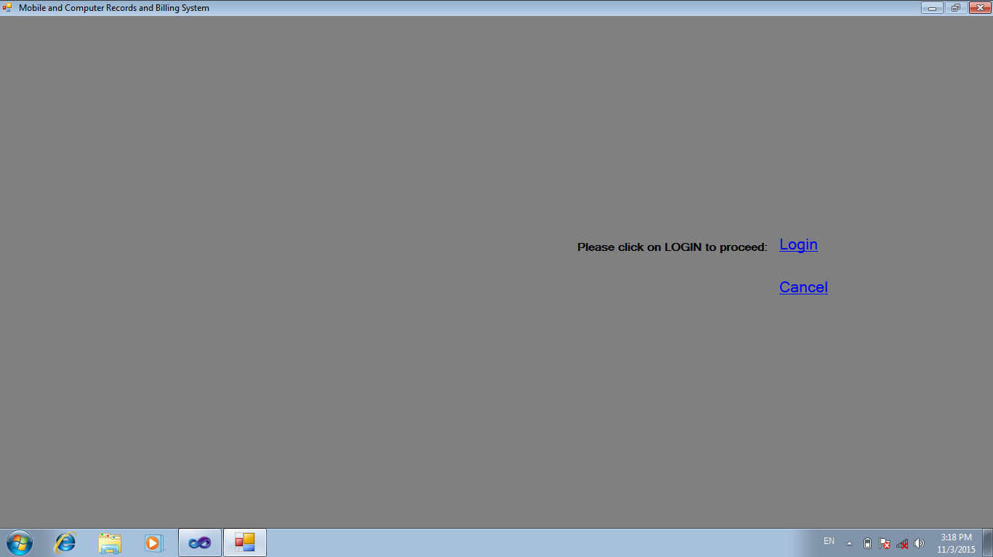

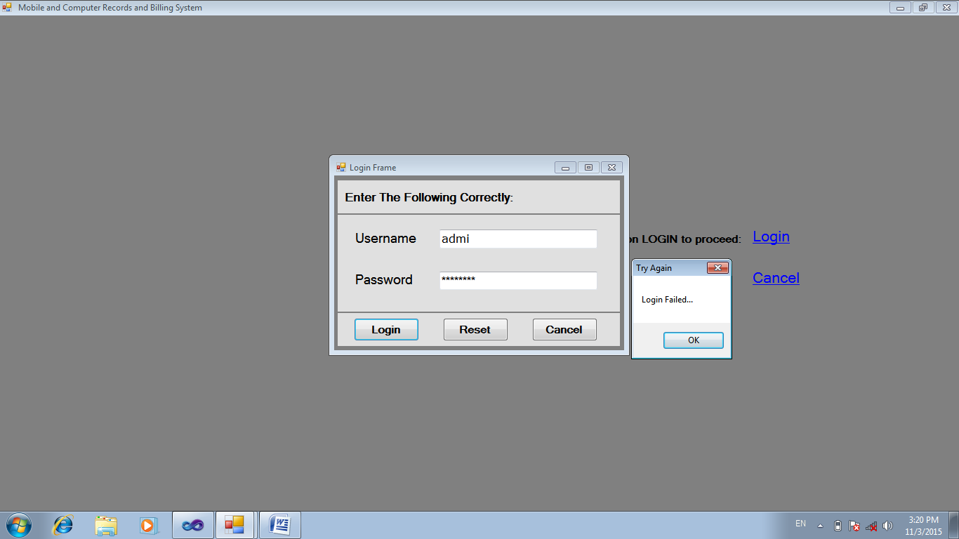

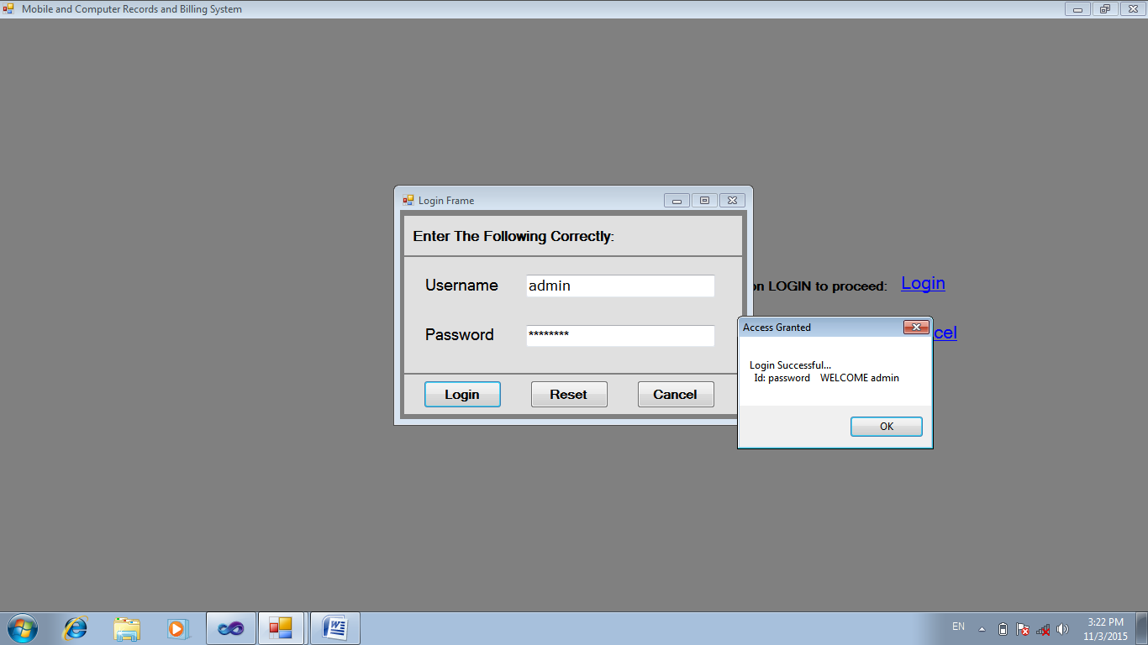

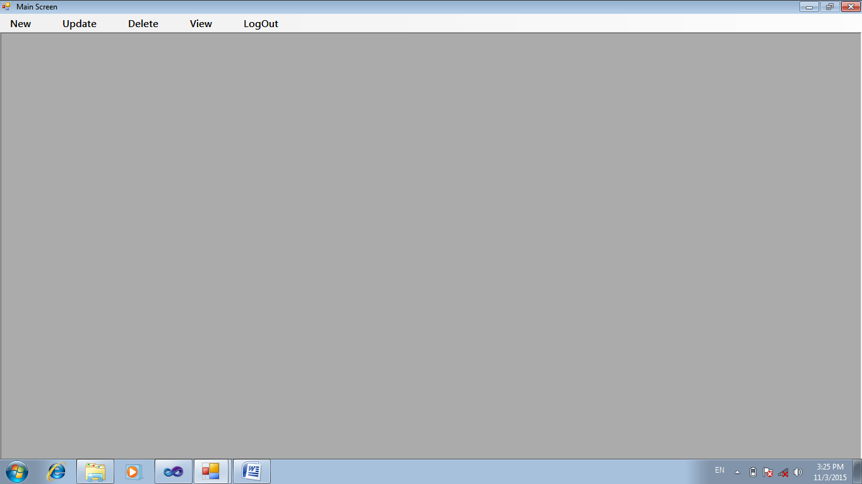

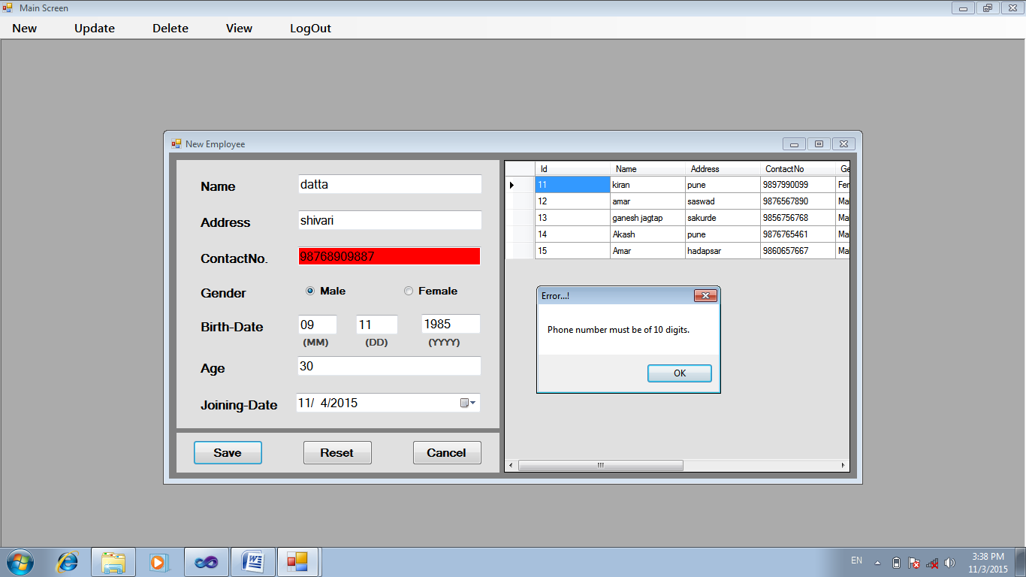

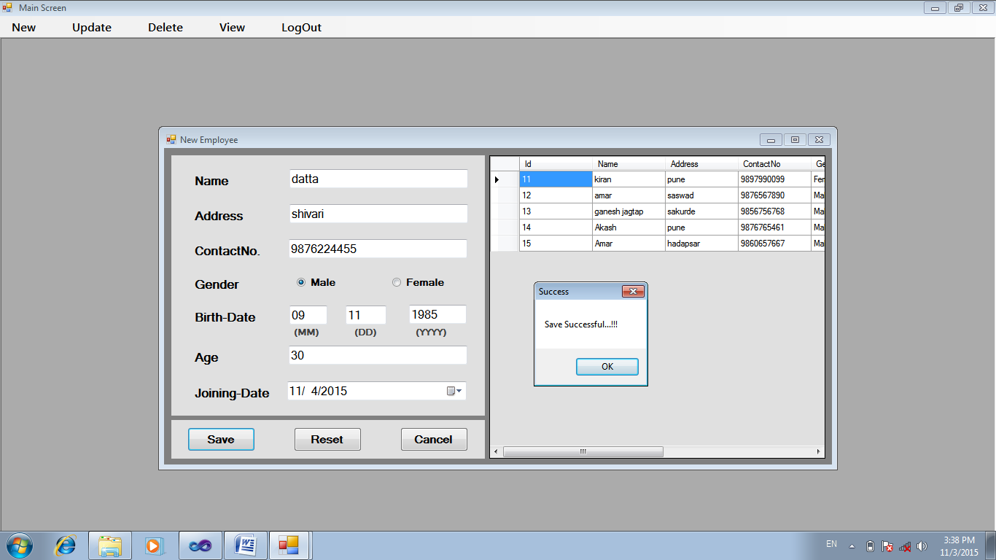

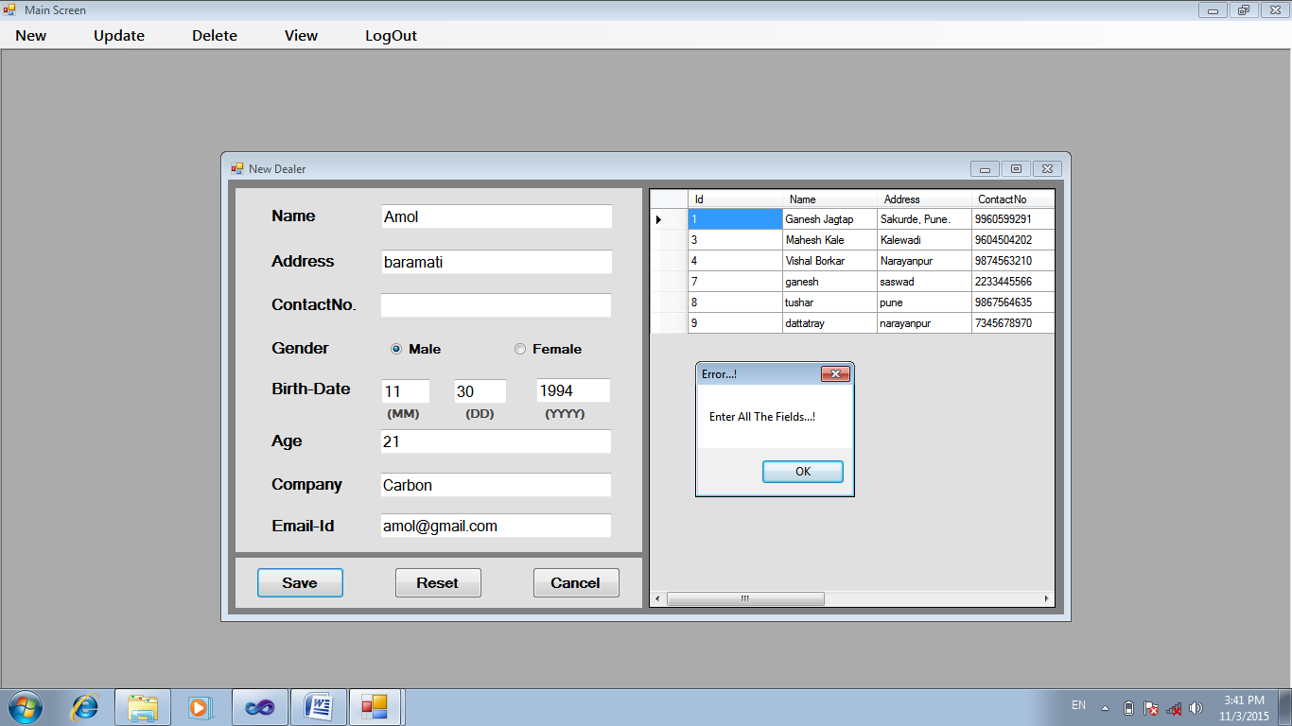

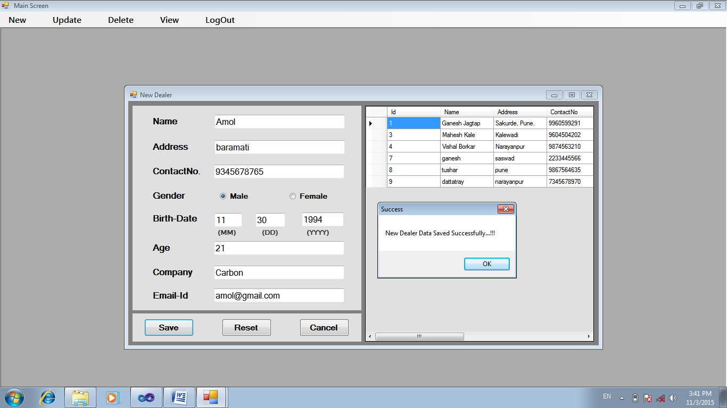

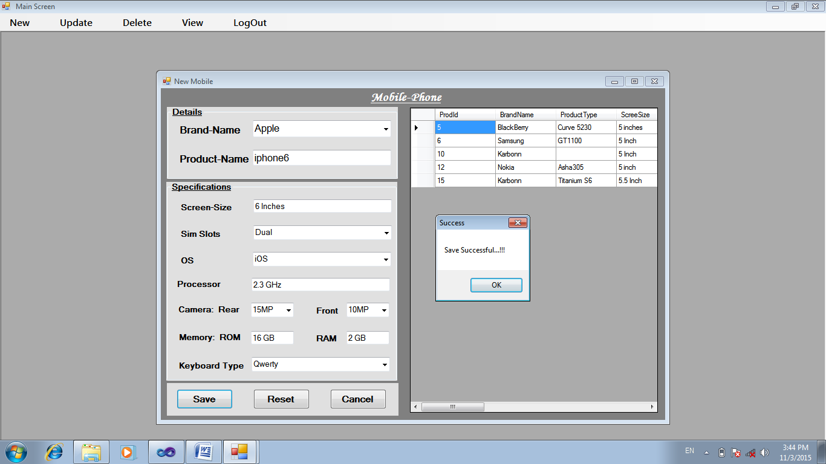

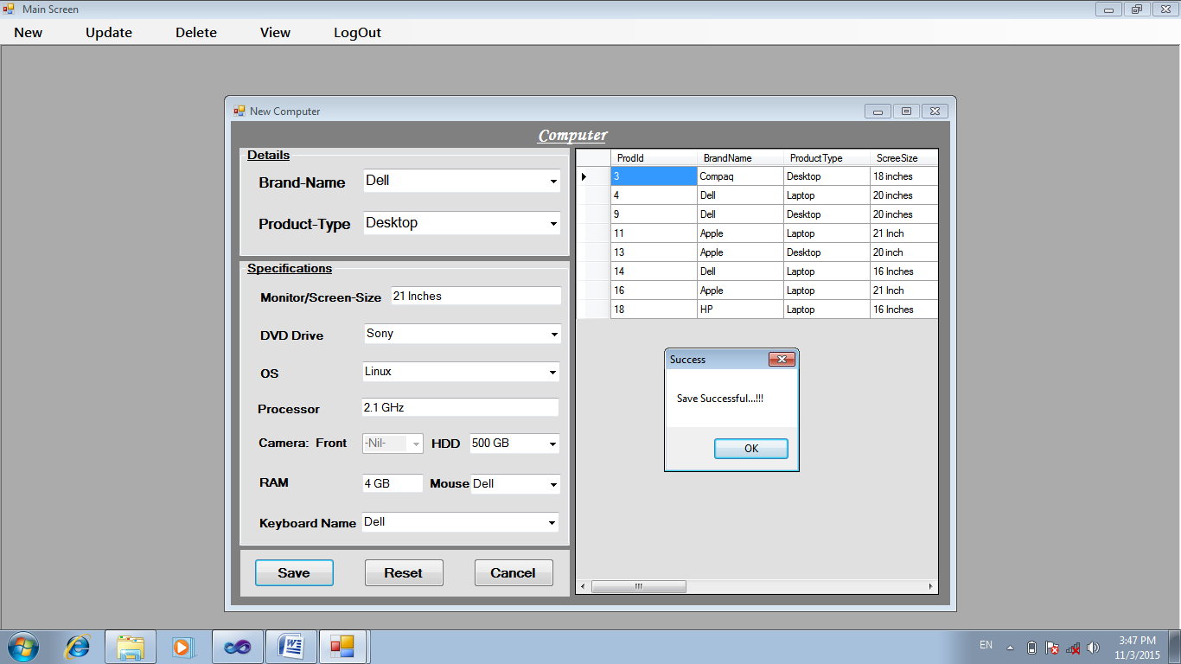

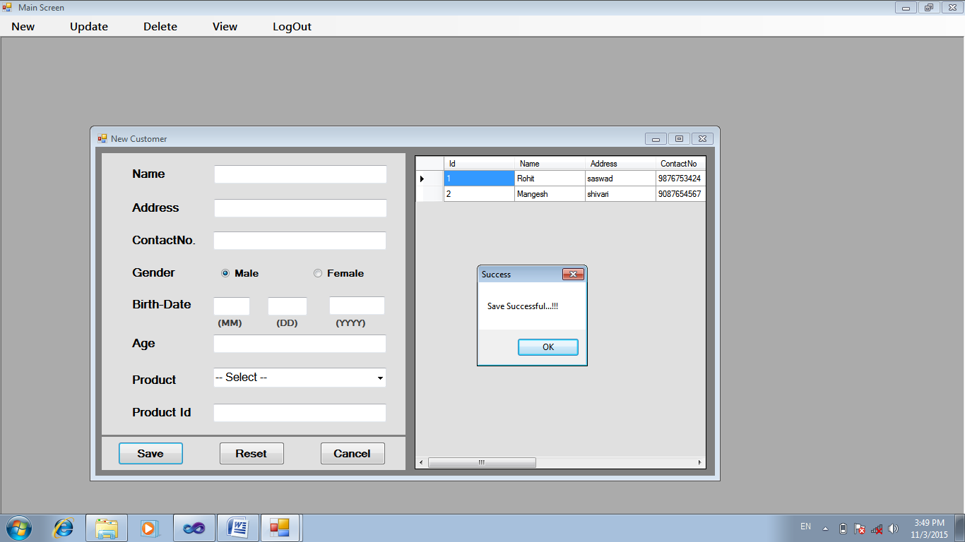

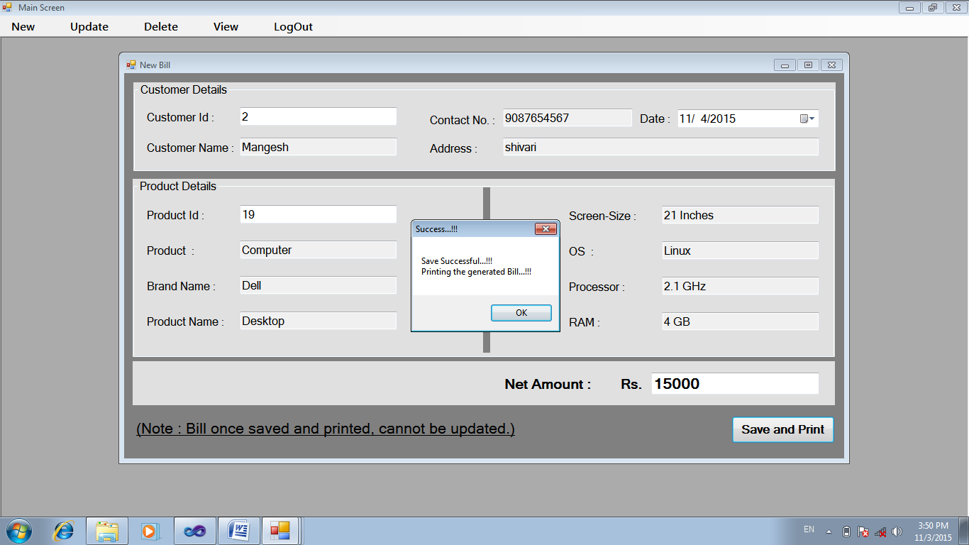

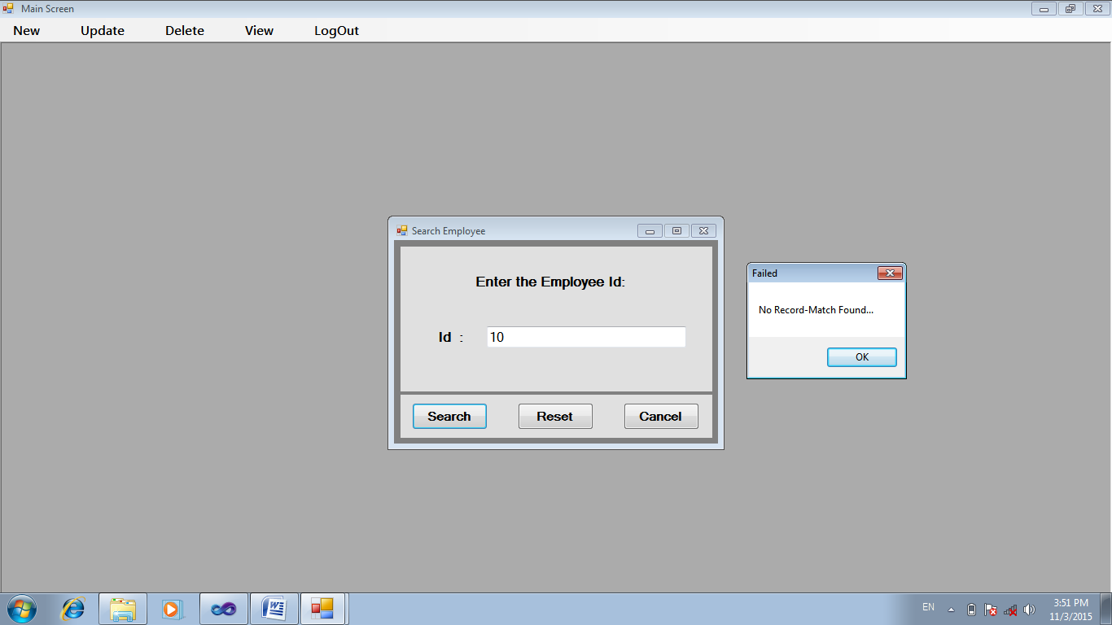

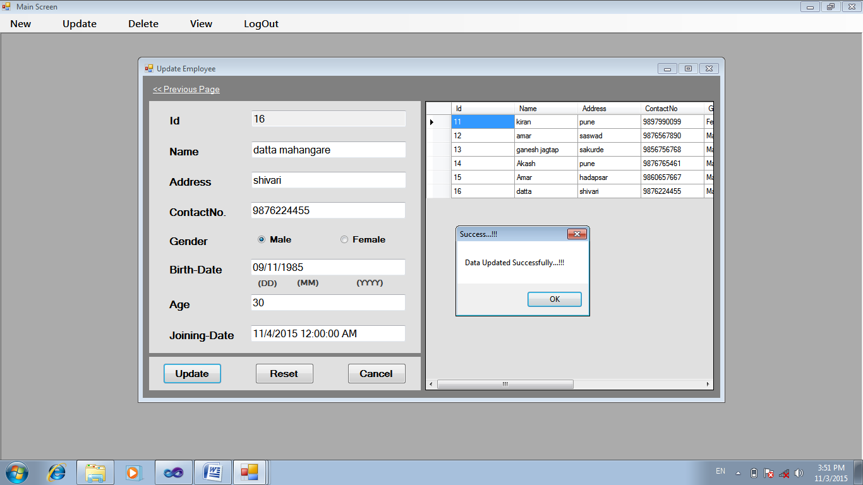

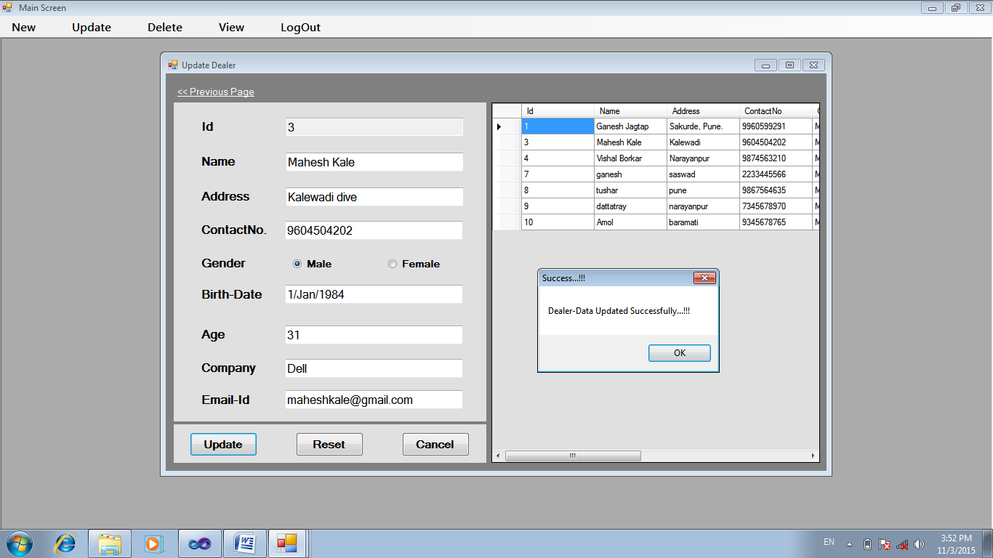

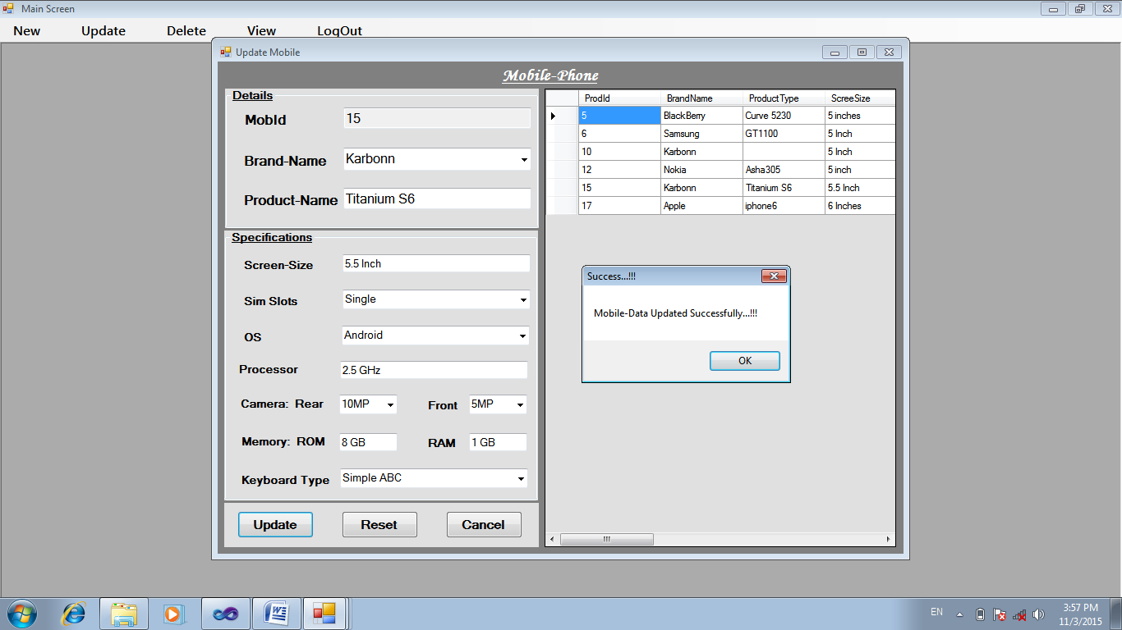

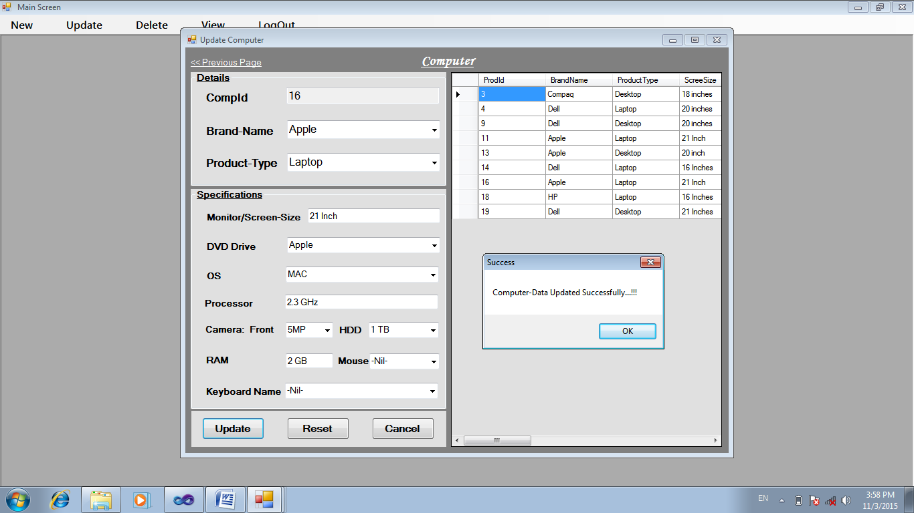

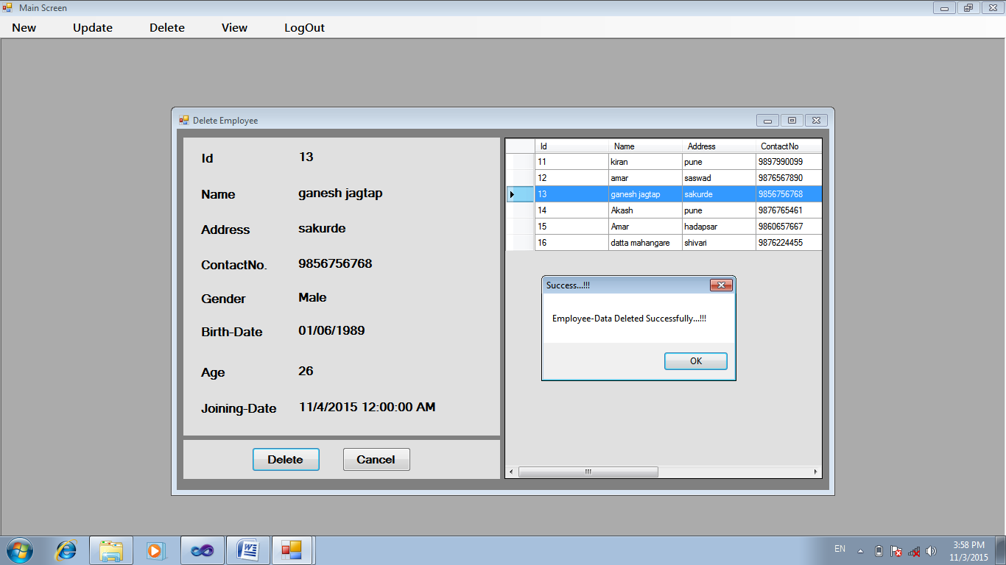

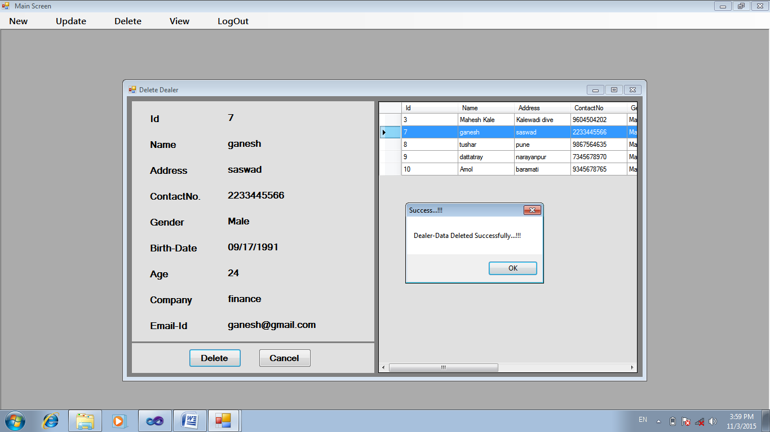

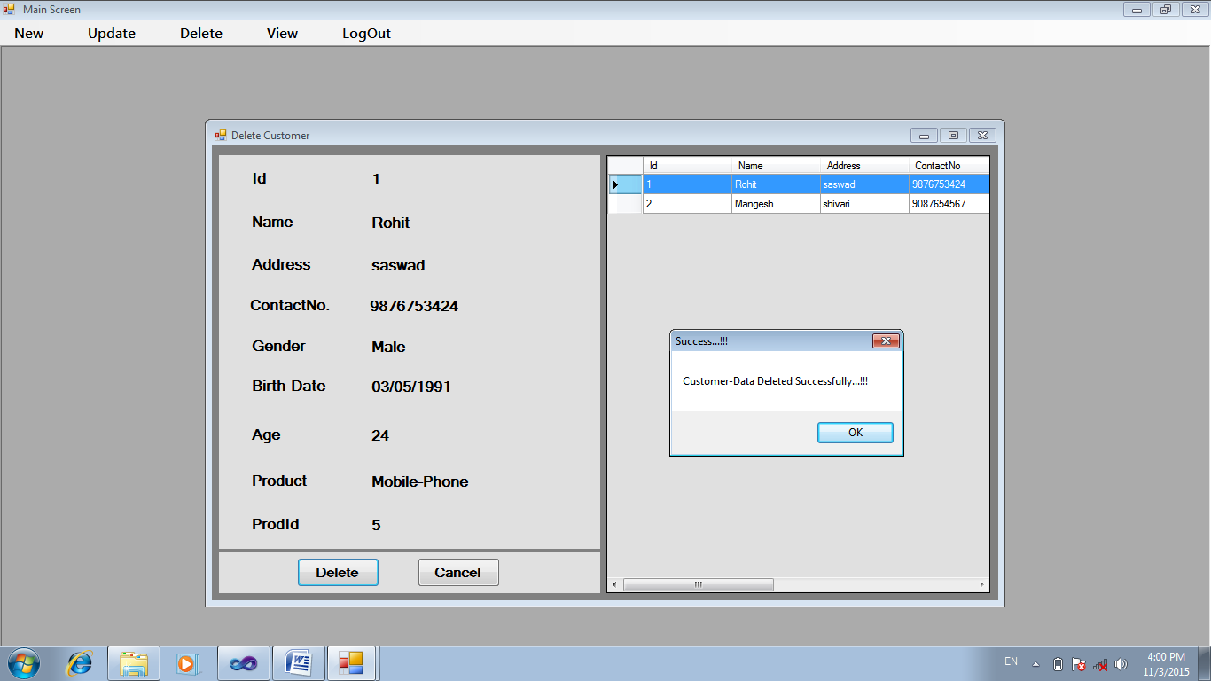

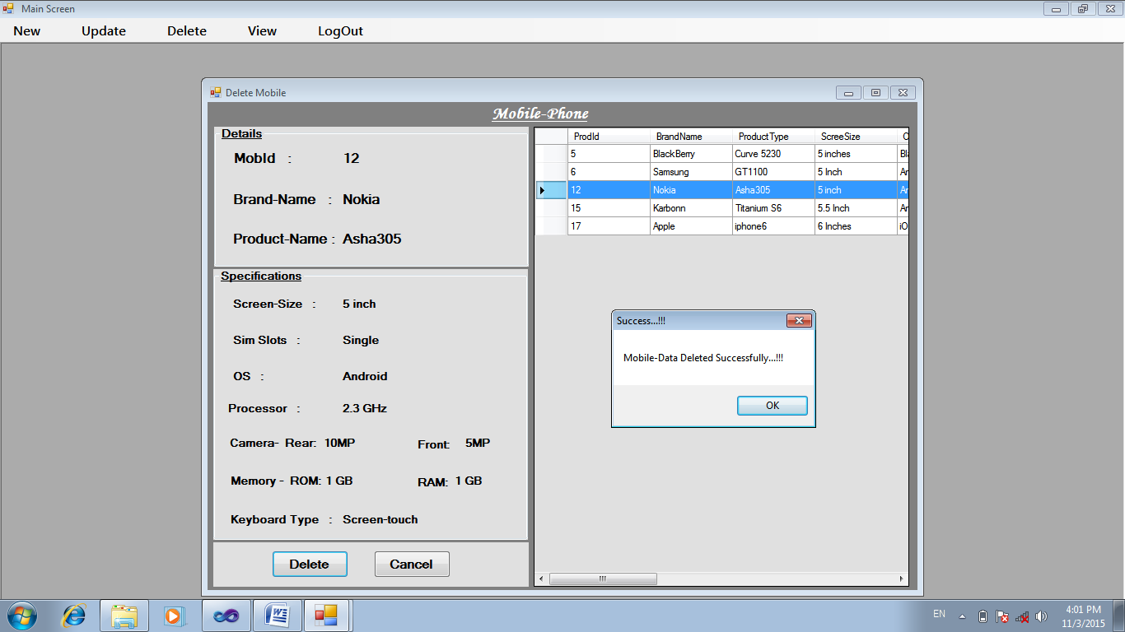

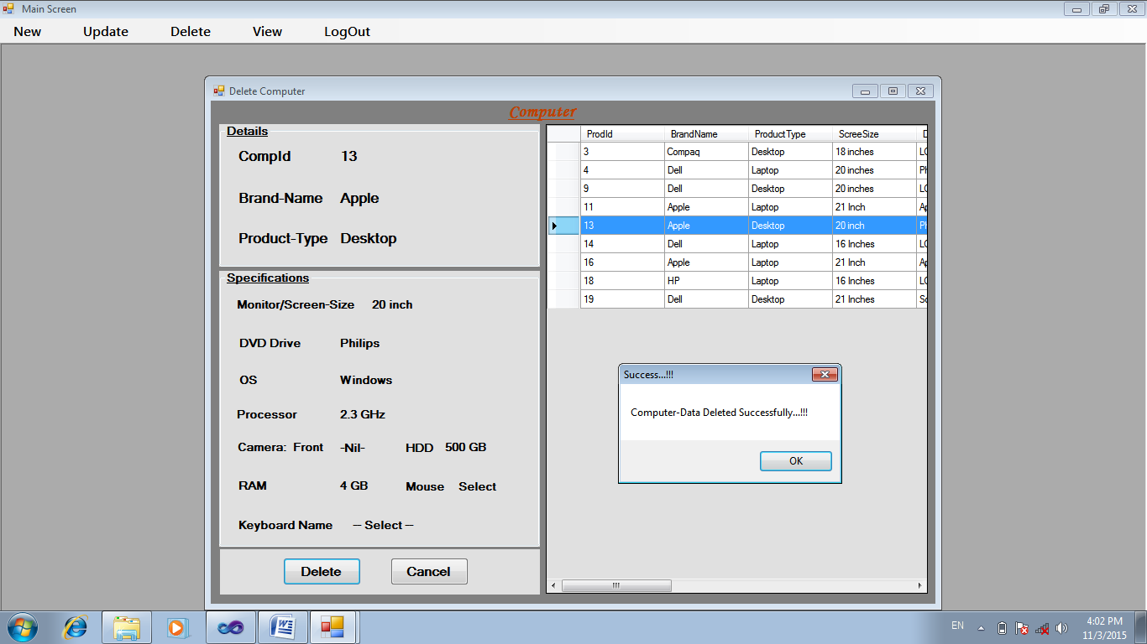

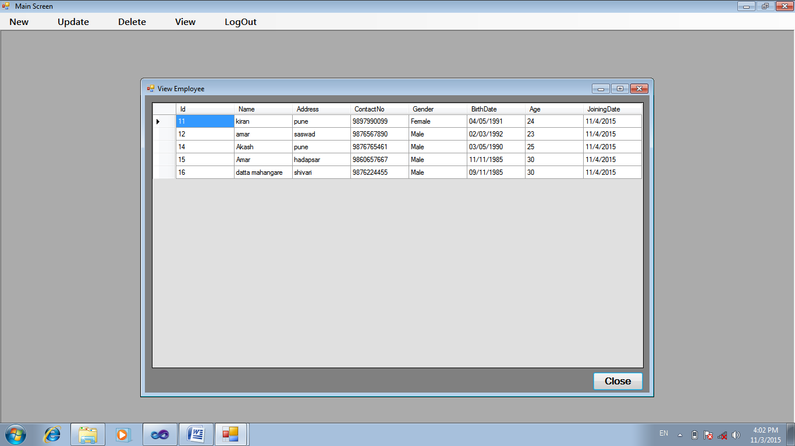

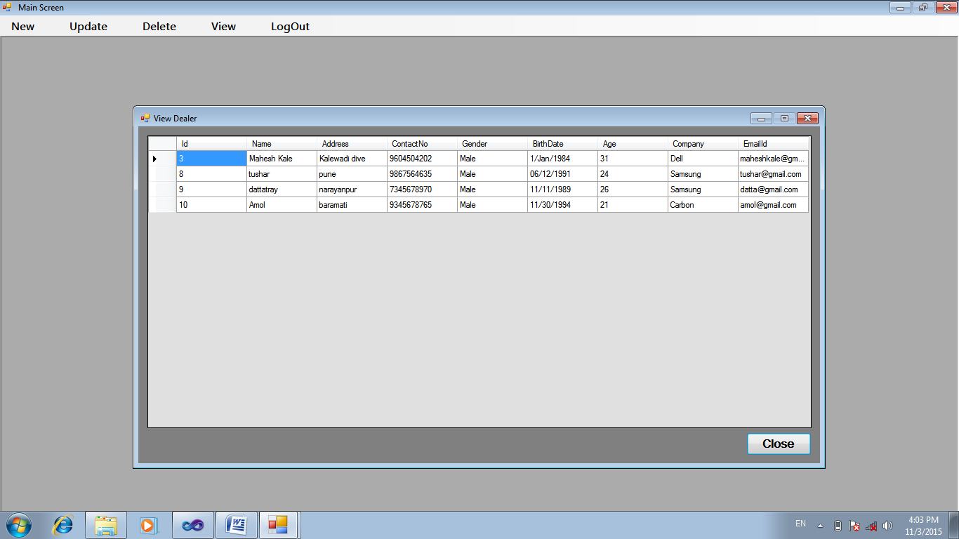

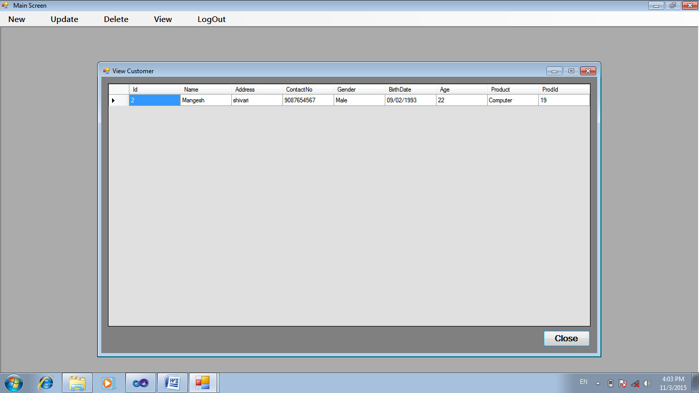

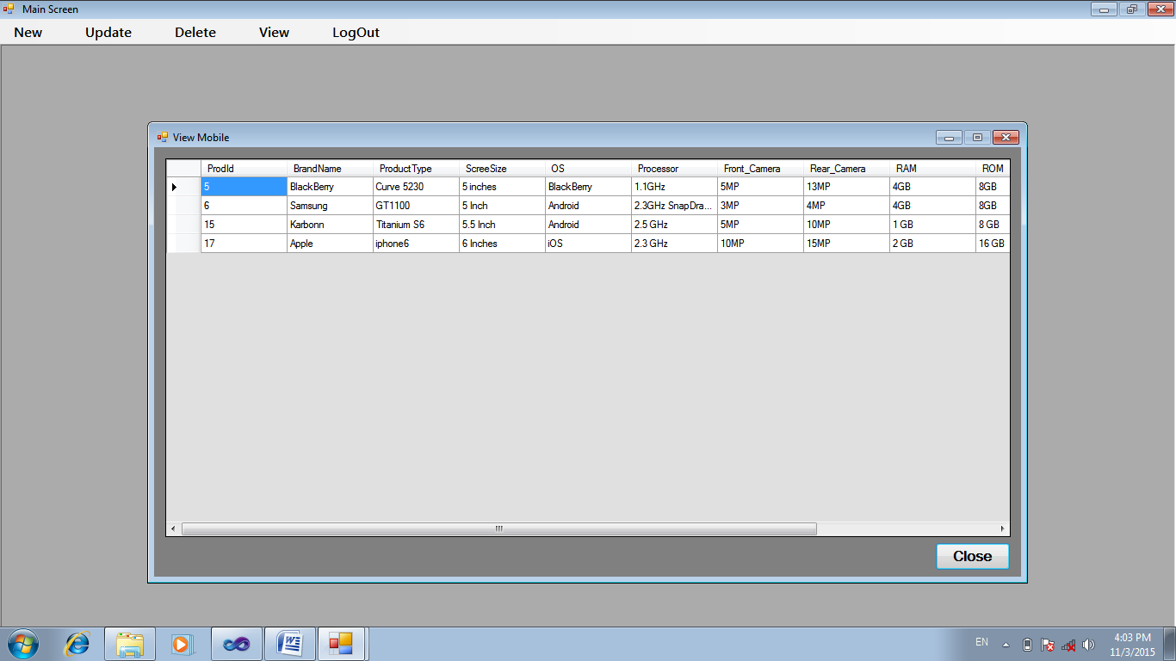

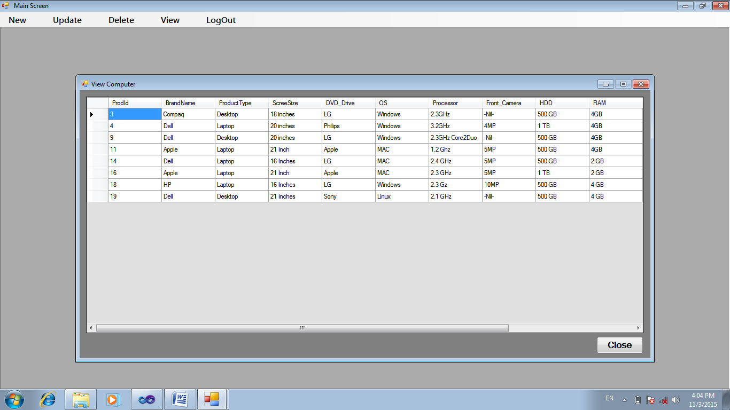

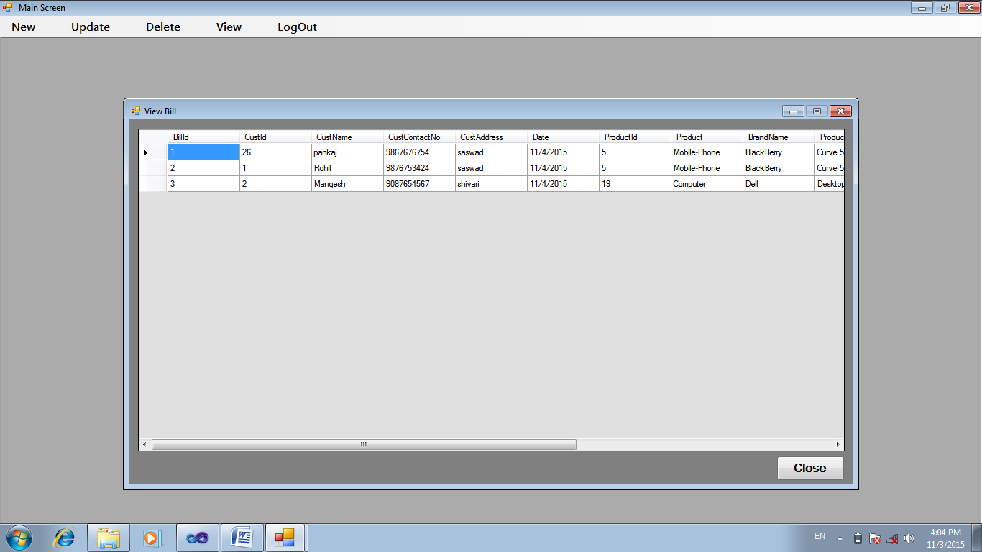

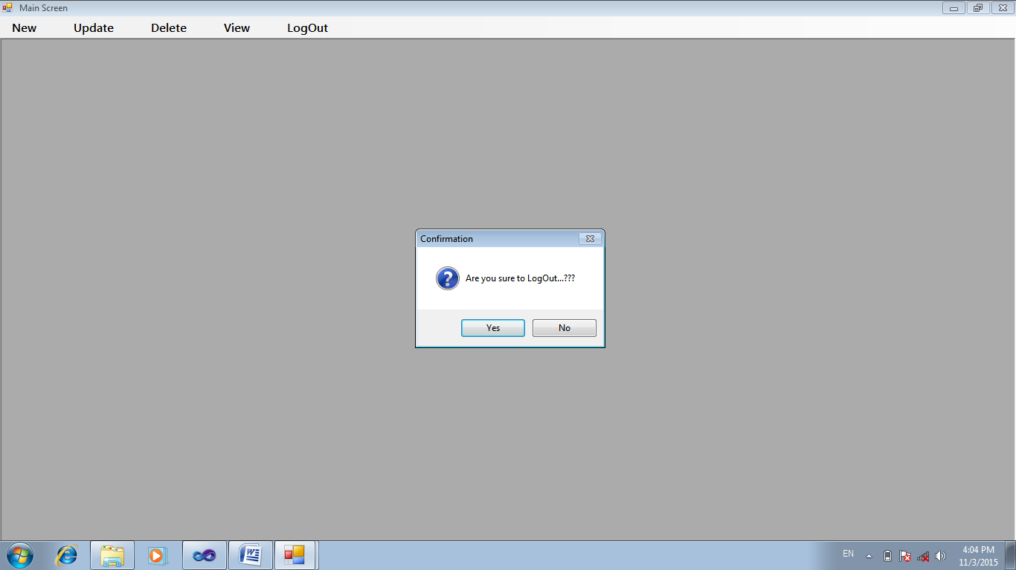

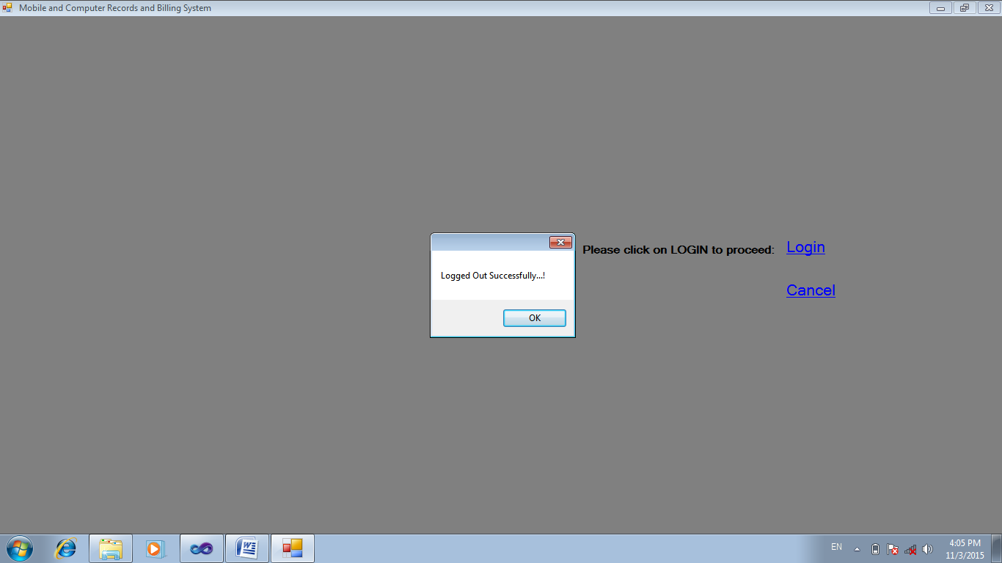

CONCLUSION

PROJECT REPORT

This project lists the details of the Dealers, Employees, Customers, Bill, Product. It may definitely bring about a significant change in the fields of maintaining the database of Mobile and Computer Shopee Management System in printed format, rather than maintaining it in handwritten format in registers.

LIMITATIONS

No system is perfectly pure. We have implemented the process of Spiral Model for development in our project. So we look forth to make our system more and more advanced. Some of the limitations of our project are:

* This system does not maintain all the records dealing with the Mobile and Computer Shopee like the stock, finishing stock warnings, etc.
* There also may be some unnoticeable changes in the project. But then too, we have used ‘Unit Testing’ for our project to test its faults.

Future Enhancements

This system is already user-friendly, but it has some drawbacks in it as discussed above. We look forth to make some changes in the proposed system as follows:-

1. We intend to FREE the Mobile and Computer Shopee from the WRITTEN WORK.
2. The stock will be maintained and warnings will be given when stock is about to finish.
3. Multiple products can be purchased and mentioned in a single bill.
4. Warning must be given for finishing stock before a week or two in order to send the purchase-order.

BibliographY

|  |  |
| --- | --- |
| Sources | Writers |
| 1. **1) Visual C#** | **TATA McGraw-Hill Publications** |
| **2)msdn.microsoft.com** | **Website** |